Modelling Pipe Risk

Condition and Consequence

2014/15

(Place on Wellington Water Report cover overprint)

Document Quality Control

This document was developed for XXX

**Report Status – Draft**

**Orignator:**

Wellington Water

**Contributors:**

Hywel Lewis

**Reviewer:**

Nicola

**Approved:**

Yon

**Version Control:**

|  |  |  |
| --- | --- | --- |
| **Asset Management Plan** | **Publishing Date** | **Electronic file location** |
| Initial draft for discussion |  |  |
|  |  |  |

Foreword

Increasing fiscal pressures, an ageing network and the desire the continue to strengthen asset management were the key drivers for improving processes for assessing condition, forecasting renewals and longer term asset planning.

Buried assets are subject to environmental degradation caused by exposure to differing soil environments, loading from expansive soils, traffic (where installed beneath roads) and building. They are subjected to various internal stresses as a result of operating conditions including pressure, flow and water quality and their structural performance can be affected by material choice, size and installation quality.

In Wellington there is an increasing amount of data on pipe condition on gravity pipes which can be used to model deterioration. Other research used, to model deterioration used for this project include research undertaken through Commonwealth Scientific and Industrial Research Organisation (CSIRO).

The models developed as part of this study build on this work, and use available international data as a basis for defining expected materials performance that can then be used to estimate remaining useful life.

The remaining useful life in the context of this report is the difference between the current age of the asset and the forecast failure (i.e. structural failure) date.

While the condition model outputs can be used to provide guidance on the future capital expenditure requirements for renewal of existing assets, they do not provide information on:

* The hydraulic performance of the three water networks
* Future growth requirements

However the outputs can be used together with the above data to provide a more informed assessment of capital requirements for ongoing operation and development of the three networks.

Table of Contents

Document Quality Control i

Foreword ii

1 Introduction 4

1.1 Purpose and Basis 4

1.2 Drivers 4

2 What We Aim to Do 5

2.1 Background 5

3 Consequence Models 6

3.1 Introduction 6

3.2 Consequence Calculator 6

3.2.1 Collection Networks 6

3.2.2 Distribution Networks 9

4 Pipe Condition Models 10

4.1 Collection Networks 10

4.1.1 Lifetime Estimator (MLM Tool) 11

4.1.2 Materials Assessed 14

4.2 Distribution Networks 15

5 Outcomes 21

5.1 Background 21

5.2 Condition Grading 21

5.3 Estimated Renewals 22

5.4 Mapping 24

5.4.1 Water Supply 24

5.5.1 Wastewater 27

5.5.2 Stormwater 30

6 Critical Pipe Management 33

6.1 Inspections 33

6.1.1 Collection Networks 33

6.1.2 Distribution Networks 34

7 Works Cited 36

Appendices I

Description of Statistical Deterioration Model I

Pressure Networks I

Notes on Failure Methods VI

# Introduction

## Purpose and Basis

There is a growing need for Wellington to find better ways to prioritize their infrastructure asset maintenance, rehabilitation and replacement projects. As the networks age, they become increasingly more challenging to assign limited capital expenditures to the repair, rehabilitation or replacement of the assets. The prudent management of pipe assets requires a reasonable assessment of the current condition coupled with a reliable way to forecast future condition.

The overall objective of this project was to describe the process adopted by Wellington Water to estimate pipe condition for Three Water Assets for Upper Hutt, Porirua, Lower Hutt and Wellington City Councils.

This report recommends a conceptual framework for developing pipe condition grade. The non-hydraulic model was developed in InfoNet and allows for the prediction of failures, and managing and optimization of operation and maintenance of distribution and collection systems.

The key outcomes of the study were:

* Estimate remaining lives for pipes within the region
* Forecast renewal
  + lengths for each of the pipe assets based on the expected lifetime
  + costs for each pipe asset based on a like-for-like diameter replacement

This report outlines:

* the basis for the development of condition and renewals models for distribution and collection models
* the adopted approaches
* the outcomes
* the recommended approaches for refinement and calibration of the model; and
* the use of the model for informing renewals forecasts, valuations and longer term development plans

## Drivers

Buried assets are subject to environmental degradation caused by exposure to differing soil environments, loading from expansive soils, traffic (where installed beneath roads) and building. They are subjected to various internal stresses as a result of operating conditions including pressure, flow and water quality and their structural performance can be affected by material choice, size and installation quality.

With a significant investment in buried pipelines, Wellington Water asset managers have an interest in understanding how these assets will deteriorate over time as this is an important factor in determining how service levels will be affected and in defining capital requirements for renewals over the medium to long term.

While short-term programmes typically use evidence-based approaches to derive renewals requirements, medium to long-term renewals programmes are typically driven by residual service life forecasts which require an understanding of likely service lives and deterioration rates and balancing asset performance with the need to maintain agreed service levels (i.e. minimising bursts, supply contamination and resultant service outages).

Increasing fiscal pressures, an ageing network and the desire the continue to strengthen asset management were the key drivers for improving processes for assessing condition, forecasting renewals and longer term asset planning.

# What We Aim to Do

## Background

It can be argued that estimating the failure date of pipe assets is one of the most difficult tasks an asset manager can do. This can be partly attributed to the difficulties associated with ascertaining a reliable measure for its physical condition.

Faced with this challenge, in 2014 Wellington Water collated a series of studies (undertaken by AECOM) geared towards the creation of a comprehensive tool set for managing three water pipe assets.

In this regard 4 main studies were collated:

1. **Consequence Models:** As the starting point for risk management, the consequence model classifies assets based on their effects following failure. The model within InfoNet has been used as a starting point and can include critical factors such as: surface water pollution, property flooding, odour / nuisance, ground water pollution, repair cost, traffic risk, rail / business disruption and disruption risk. Other critical factors used to supplement these risks include whether the pipe is under a building and access restrictions.

The model can define what subsequent management practices to be used for high, medium and low consequence pipes. For pipes with a low consequence, failure can be tolerated and the goal is to develop policies that balance life-cycle costs with acceptable levels of service. For pipes with high consequence, failure should not be acceptable and hence a more proactive policy driven by actual pipe condition and deterioration factors should be pursued.

1. **Pipe Condition Models**: The challenge associated with developing a pipe condition model for pipes stems from the lack of reliable data on which to base the forecast on. The pipe condition models for collection and distribution networks have been independently developed.
   1. The collection model is based on the Maximum Likelihood Model (MLM) within the InfoNet package.
   2. The distribution model is predominantly based on deterioration analysis carried out by Paul Davis (CSIRO)
2. **Critical Pipe Management:** This part of the study identifies an approach to be developed based on proactive collection of condition information. The framework is based on condition rating and the consequence of failure.
3. **Information Framework:** The components previously described all require good quality reliable information. The framework is designed to be improved over time and provide a mechanism to make decisions on pipe assets. The framework has been constructed in InfoNet, however, given time and resources could form part of other support systems being used in the Wellington region.

# Consequence Models

## Introduction

The intent of the consequence models is to identify pipes that have a high operational criticality. In other words “which pipes will have the greatest impact to the City, should they break”. Once a list of critical pipes has been identified it’ll be possible to focus effort and resources on these assets before they fail.

The process of identifying critical pipes is often a subjective process and will require the local authorities to sit round a room and discuss the selection and ranking of parameters in which they feel affects rehabilitation and replacement costs. Because there is currently no adopted process for the Wellington region a simplified process within InfoNet has been adopted to rank the consequence of failure from 1 to 5.

Examples of criticality parameters include pipe characteristics such as pipe material, cover depth, land use, number of occupants / key water users, land use and sensitive areas. Criticality factors used for this study have been highlighted in bold in Table 3‑1 and Table 3‑9 below.

## Consequence Calculator

The Consequence Calculator in InfoNet was used to calculate the Consequence score for pipes. Consequence score values can subsequently be used in conjunction with Likelihood score (or condition grades) values by the Risk Assessment tool to determine a risk score for each pipe. This risk score will then be used to assist with the managing and optimization of operation and maintenance of distribution and collection systems.

### Collection Networks

The following sections provide details of the calculations carried out by the consequence calculator for the different network types.

Critical factors that are unchecked in the criticality calculator are ignored when scoring the pipe. Critical factors are assessed as follows:

| Critical factor | Individual criticality rating |
| --- | --- |
| Surface water pollution risk Property flooding risk Odour/Nuisance risk Ground water pollution risk **Repair cost risk** Traffic risk score Rail/Business disruption risk | Consequence rating determined from values entered manually in pipe data fields.  Note that Repair cost risk and Traffic risk score may be calculated automatically  (scores range from 0 to 5, 5 being the worst) |
| Under building | Consequence rating of 5 is assumed for pipes |
| Access restrictions | Consequence rating of 3 is assumed for pipes |

Table 3‑1 Critical Factors – Collection Networks

Factors used for the study are highlighted in bold in Table 3‑1 above.

* Surface water pollution risk: This factor is used to represent pipes which if damage could cause a risk to surface water pollution
* Property flooding risk: This factor is used to represent pipes which either cause property flooding or fall within an area at risk of flooding
* Odour/Nuisance risk: This factor is used to represent pipes which currently cause nuisance (odour or otherwise)
* Ground water pollution risk: This factor is used to represent pipes which are in wet ground
* Repair cost risk: Explained in detail in the following sections.
* Traffic risk score: Explained in detail in the following sections.
* Rail/Business disruption risk: This factor is used to represent pipes if damaged could result in disruption to business and or transport.
* Under building: Pipes within 0.5m of a building have been located
* Access Restrictions: This factor is used to represent pipes where there are access restrictions such as vehicle access

The Consequence Calculator may be used to automatically calculate Repair cost factor, Repair cost risk and Traffic risk score values for each pipe.

#### Calculating repair cost risk and repair cost factor

A repair cost risk and repair cost factor may be calculated based on pipe properties and ground type. The repair cost factor may then be used in conjunction with traffic data to calculate a traffic delay consequence rating.

Repair cost risk and repair cost factor values are calculated based on pipe depth, pipe material, pipe size and ground type, where:

* Pipe depth is determined from the average of US depth from cover and DS depth from cover values, (if only one value is specified, the single value will be used)
* Pipe material is assumed to be brick if either US pipe material or DS pipe material field set to BR (Brick)
* Pipe size is determined from the larger of the values in the US width and DS width fields
* Ground type is determined from the Ground type field

The Repair cost factor and Repair cost risk pipe fields will be updated with the cost factor and cost risk values according to the following tables. Field values will be set to zero for pipes that do not have adequate data to determine a value.

| Depth (m) | 1.0 - 1.99 | 2.0 -2.99 | 3.0 -3.99 | 4.0 - 4.99 | 5.0 - 5.99 | 6.0 + |
| --- | --- | --- | --- | --- | --- | --- |
| Repair Cost Factor | 1 | 2 | 3 | 4 | 5.5 | 7 |
| Good ground |
| Repair Cost Factor | 1.5 | 2 | 3.5 | 5 | 6.5 | 8.5 |
| Bad ground |
| Repair Cost Risk | 1 | | 3 | | 5 | |

Table 3‑2 Pipes up to and including 900 mm diameter – Collection Networks

| Depth (m) | 1.0 - 1.99 | 2.0 -2.99 | 3.0 -3.99 | 4.0 - 4.99 | 5.0 - 5.99 | 6.0 + |
| --- | --- | --- | --- | --- | --- | --- |
| Repair Cost Factor | 4 | 7 | 13 | 19 | 26 | 33 |
| Good ground |
| Repair Cost Factor | 5.5 | 9 | 16 | 24 | 31 | 40 |
| Bad ground |
| Repair Cost Risk | 3 | 5 | | | | |

Table 3‑3 Pipes with more than 900 mm diameter and all brick sewers – Collection Networks

Major sewers are assigned a minimum Repair cost risk according to the following:

| Pipe properties | Repair Cost Risk |
| --- | --- |
| Combined/storm sewers > 1500 mm diameter | 5 |
| Foul sewers > 600 mm diameter | 5 |
| Combined/storm sewers > 600 mm diameter but less than 1500 mm diameter (inclusive) | 3 |
| Foul sewers > 450 mm diameter but less than 600 mm diameter (inclusive) | 3 |

Table 3‑4 Minimum Repair cost risk – Collection Networks

#### Calculating traffic delay risk score

The value in the Traffic level field and the setting of the Traffic divertable field are used in conjunction with the Repair cost factor (RCF) to determine a Traffic risk score, calculated based on the road traffic delay overall cost model. Repair cost factor may be manually specified or calculated automatically by the consequence calculator (see above). An overall cost factor is calculated as follows:

| Traffic flow (vehicles/day) | Roads without adequate diversion | Roads with adequate diversion |
| --- | --- | --- |
| 5,000 - 7,499 | 4.8 x RCF | 1.6 x RCF |
| 7,500 - 9,999 | 6.3 x RCF | 1.9 x RCF |
| 10,000 - 12,499 | 7.8 x RCF | 2.1 x RCF |
| 12,500 - 14,999 | 9.3 x RCF | 2.4 x RCF |
| 15,000 - 17,499 | 10.8 x RCF | 2.6 x RCF |
| 17,500 - 19,999 | 12.3 x RCF | 2.9 x RCF |
| 20,000 + | 13.8 x RCF | 3.1 x RCF |

Table 3‑5 Overall cost factors (OCF) – Collection Networks

A traffic risk score is then determined:

| Overall cost factors (OCF) | 0 -2.9 | 3.0 - 5.9 | 6.0 + |
| --- | --- | --- | --- |
| Traffic risk score | 1 | 3 | 5 |

Table 3‑6 Overall cost categories – Collection Networks

### Distribution Networks

The consequence calculator uses the information in the pipe properties to assess the ratings for individual service risks for the pipe. The Consequence score for the pipe is then set as the highest of the individual ratings. Individual ratings for each pipe are calculated as follows:

| Critical factor | Individual criticality rating |
| --- | --- |
| Disruption risk | Rating determined from value entered in pipe Disruption risk field. |
| Under building | Rating of 5 is assumed for pipes with Under building field checked. |
| Access restrictions | Rating of 3 is assumed for pipes with a value set in the Access restrictions field. |

Table 3‑7 Critical Factors – Distribution Networks

#### Ratings based on occupancy and pipe diameter

Ratings are calculated based on the number of customers supplied by the pipe and the internal diameter of the pipe. The criteria to be used to determine a consequence rating are defined in the Criticality matrix in the Consequence Calculator. The criteria in the calculator can be edited, rows may be deleted from the grid or further values added to the bottom of the grid.

| Score | Occupancy > | Key Occupancy > | Internal Diameter > |
| --- | --- | --- | --- |
| 1 | 0 | 0 | 50 |
| 2 | 10 | 0 | 100 |
| 3 | 50 | 1 | 150 |
| 4 | 100 | 2 | 200 |
| 5 | 200 | 3 | 250 |

Table 3‑8 Consequence Calculator – Distribution Networks

The Criticality score field of the pipe is updated with the consequence score calculated from the Criticality matrix. If the Criticality score is greater than the consequence ratings determined from the Critical factors, the Criticality score will be the value with which the pipe Consequence score field will be updated.

| Consequence | Description |
| --- | --- |
| Score | Consequence rating. |
| Occupancy | Number of customers supplied by the pipe. Calculated as the sum of the Occupancy values of Property objects associated with the pipe.  If a property does not have an Occupancy specified, the Default occupancy value specified in the Consequence Calculator is used for that property. |
| Key  Occupancy | Number of key customers supplied by the pipe. Calculated as the sum of the Occupancy (Key) values of Property objects associated with the pipe.  If a property does not have an Occupancy (Key) specified, the Default key occupancy value specified in the Consequence Calculator is used for that property. |
| **Internal Diameter** | Diameter of the pipe taken from value specified in Internal diameter field of pipe. |

Table 3‑9 Consequence Matrix - Distribution Networks

# Pipe Condition Models

The approaches adopted for forecasting medium to long-term renewals requirements for buried assets have progressively improved over the years.

The approach was to use the base-life for a particular asset (generally defined by Asset Management Plan (AMP) estimates and more recently using a statistical tool within InfoNet).

Non-pressure networks generally have less uniform deterioration characteristics because of the variability of flows within the pipes – often resulting in pipes not being completely full. This variability in internal environment is difficult to model and coupled with the variability in external loading on the pipes makes statistical deterioration models less reliable.

## Collection Networks

In order to estimate the lifetime of non-pressure networks we used the lifetime estimator tool within InfoNet. The Lifetime Estimator was used to carry out a statistical analysis on pipe failure and survival data in order to estimate pipe expected lifetime and likelihood of failure.

Infill Missing Data (pipe depth, material, age etc.)

Update Pipe Class

for dominant material types:

EW

AC

CONC

PVC

Update AMP lifetimes for all other material types

FAILURE ANALYSIS

MLM tool within InfoNet

* CCTV Failure ages (e.g. where a CCTV condition grade is greater than or equal to 5)
* Pipe Incidents (such as collapse, broken pipe that are not related to external forces.
* Additional failures (such as pipe renewals lists)

CONDITION RATING TABLES

Estimate Condition based on remaining useful life

RENEWALS EXPENDITURE PROFILE

Unit Rates

Figure 4‑1 Approach used to forecast renewals expenditure profile for collection networks

Figure 4‑1 above shows the approach used to develop estimate of condition. The condition of the asset (or its remaining useful life) has then been used to forecast the renewals expenditure profiles.

The point of intervention in practice will be based on an economic assessment which takes into account maintenance costs and the cost of replacement. For the purposes of renewals forecasting I have chosen the intervention age to be at 90% along the its cumulative probability of failure curve. The age of the asset is then subtracted to give an indication of residual service life.

### Lifetime Estimator (MLM Tool)

Where there the pipe condition is well known, for example through CCTV Surveying, the likelihood of pipe failure can be estimated with some confidence. Where the pipe condition is not known, it is necessary to use statistical techniques to estimate pipe lifetime.

There are various statistical techniques available for using failure data to estimate asset lifetime. One of the most common methods is to use Weibull analysis of failure data to provide an estimate of failure probability over time. This module within InfoNet will use the Maximum Likelihood method to select the most appropriate Weibull curve and allow the user to use this information to estimate the likelihood of pipe failure (Weibull profiled displayed in Figure 4‑2 to Figure 4‑9 below).

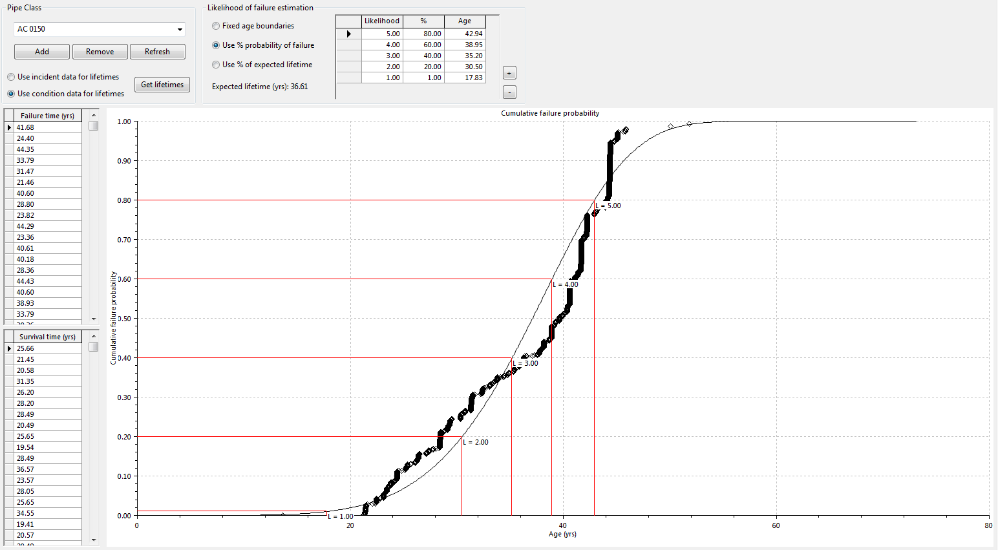

Figure 4‑2 MLM - Non-pressure small AC wastewater pipes (PCC)

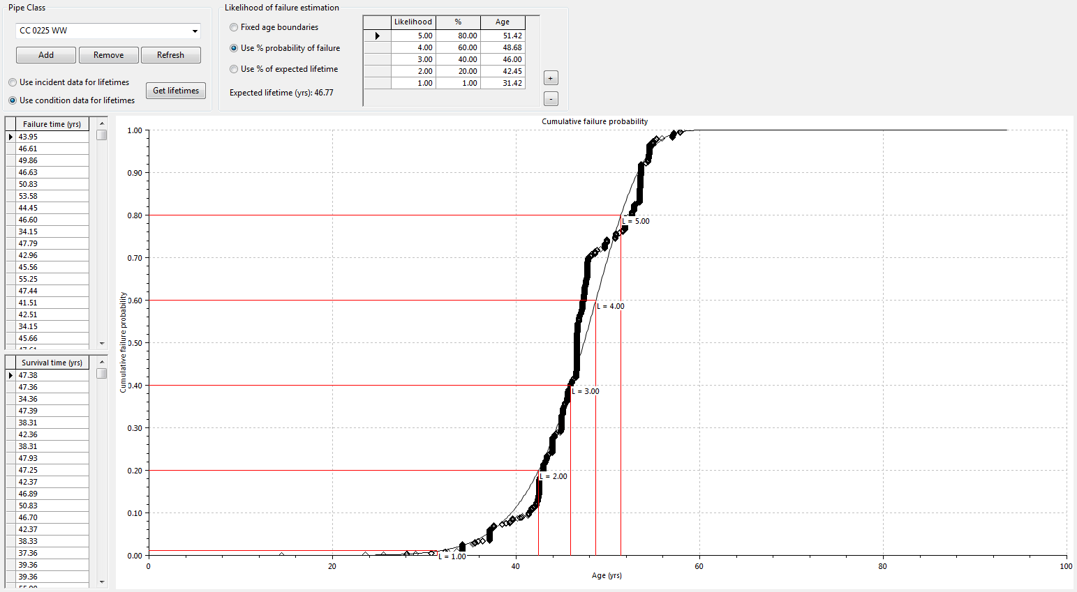

Figure 4‑3 MLM - Non-pressure small concrete wastewater pipes (PCC)

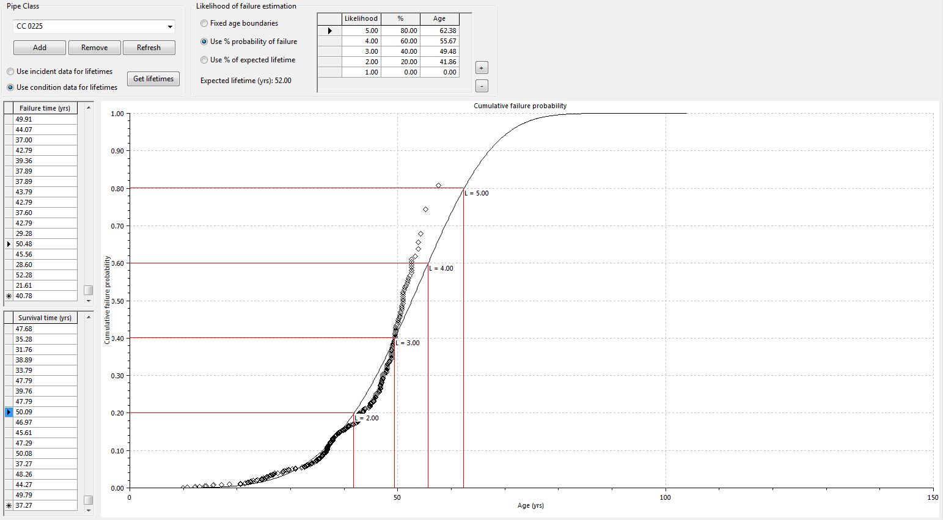

Figure 4‑4 MLM - Non-pressure small concrete stormwater pipes (UHCC)

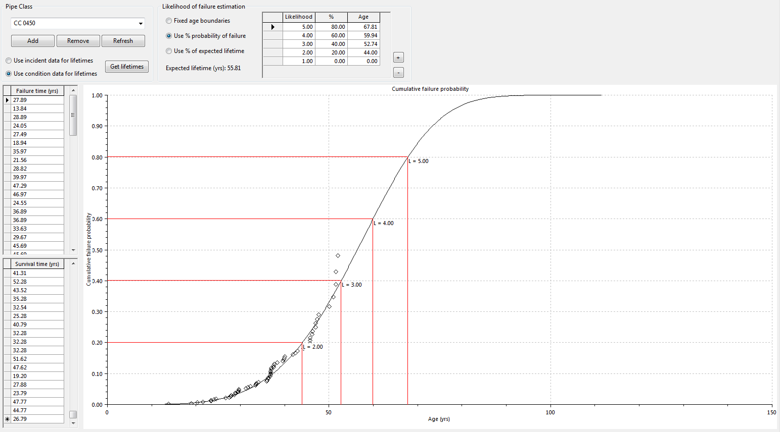

Figure 4‑5 MLM - Non-pressure medium sized concrete stormwater pipes (UHCC)

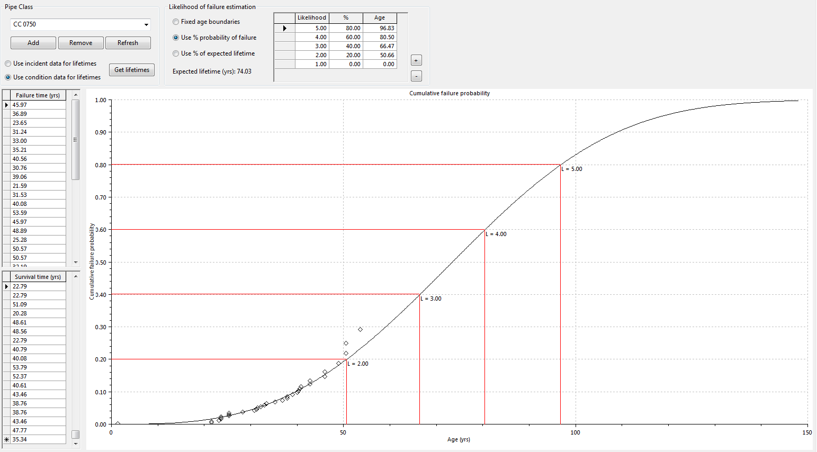

Figure 4‑6 MLM - Non-pressure Large Concrete stormwater pipes (UHCC)

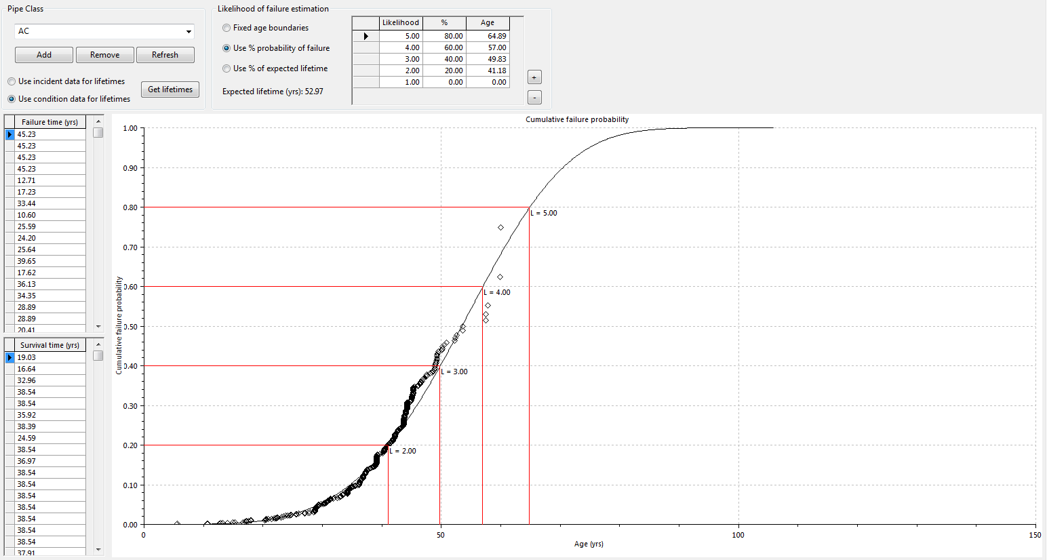

Figure 4‑7 MLM - Non-pressure Class C AC pipes (UHCC)

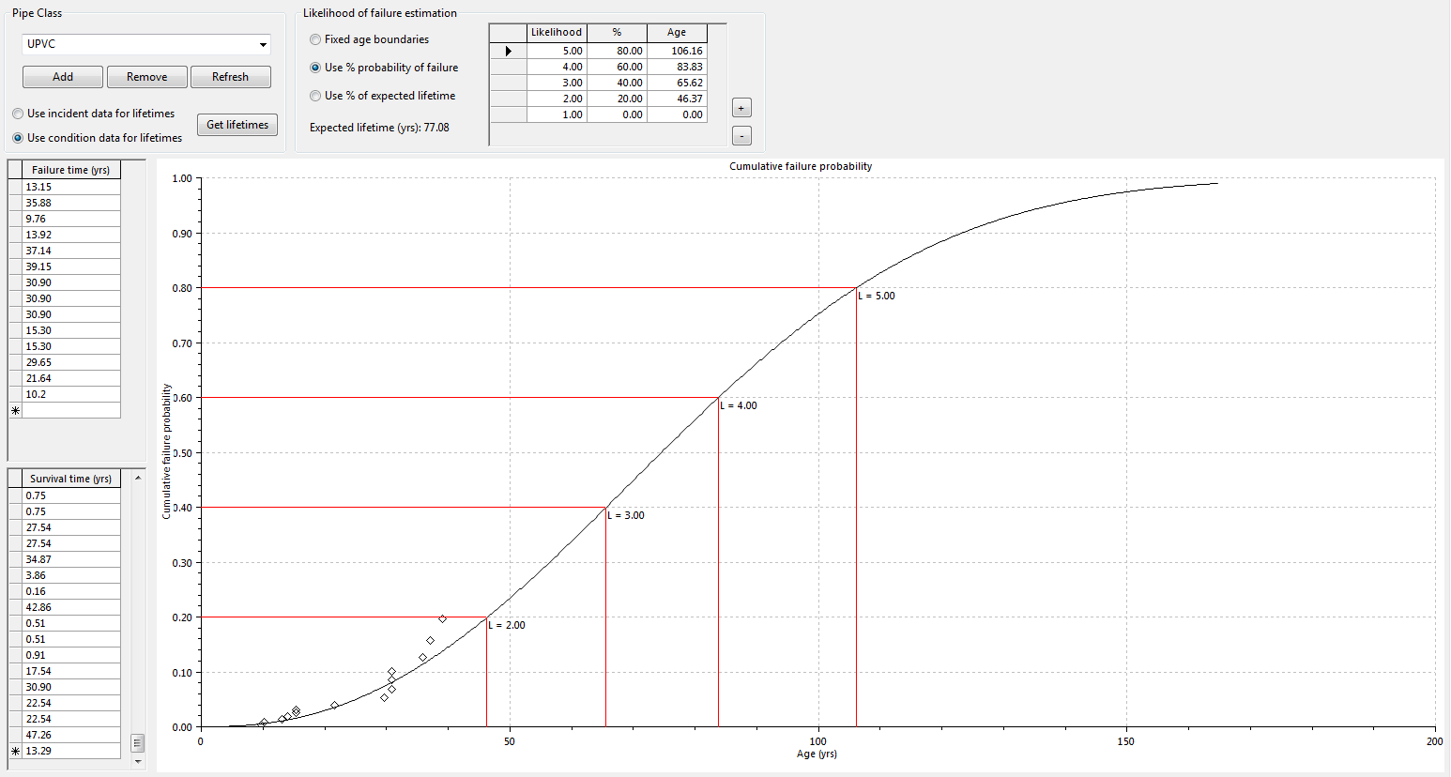

Figure 4‑8 MLM - Non-pressure UPVC pipes (UHCC)

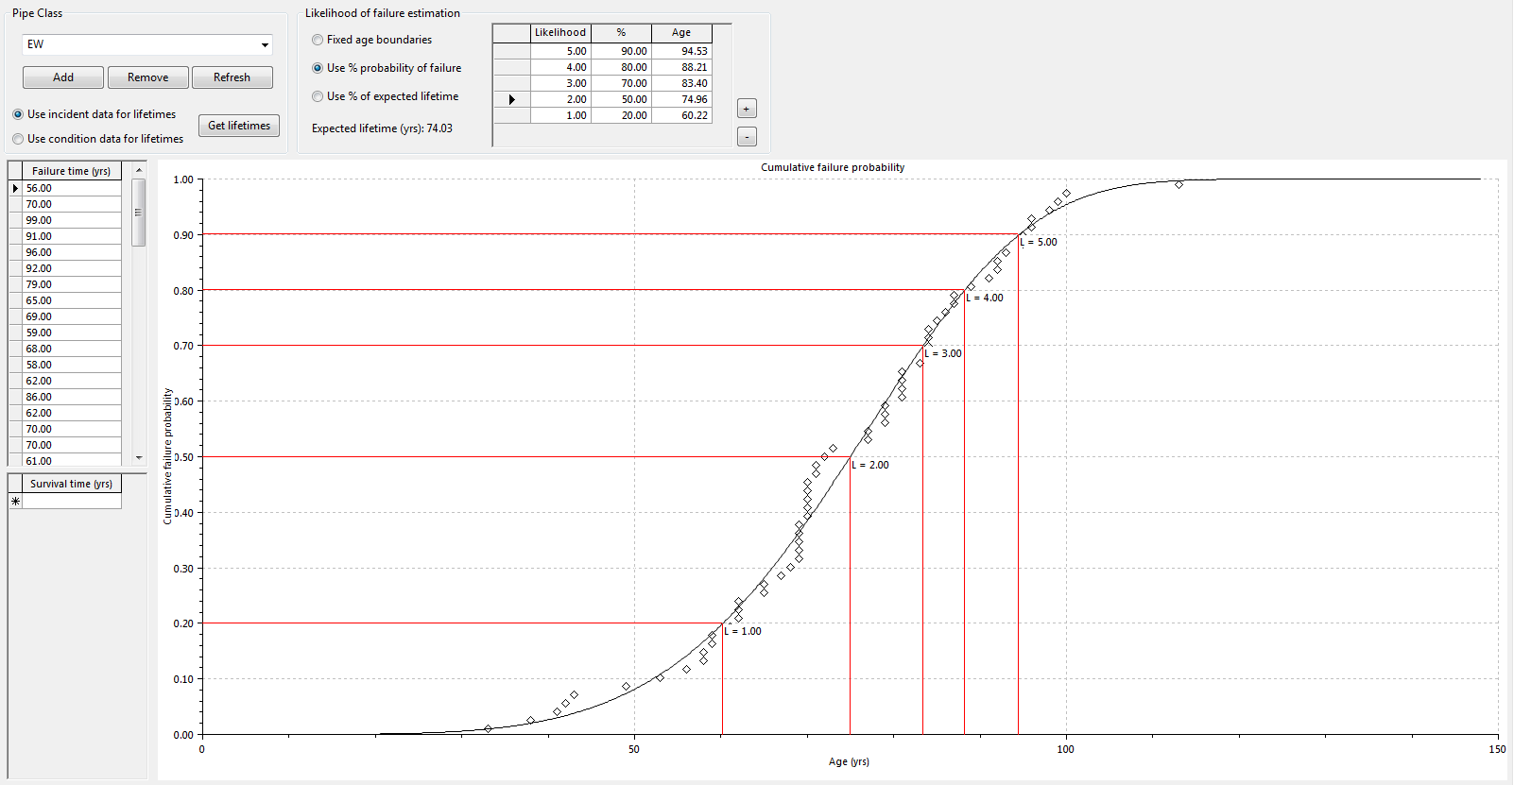

Figure 4‑9 MLM - Non-pressure EW pipes (WCC)

### Materials Assessed

CCTV Surveys were available for UHCC, WCC and PCC council areas.

* UHCC: possessed the most comprehensive asset and survey database.
  + Hence a number of realistic deterioration profiles were produced for the main material types.
  + CCTV surveys were carried out across the catchment and hence were not focussed in the bad or good areas.
* HCC: limited CCTV data was collected for this council area.
  + CCTV surveys carried out have historically been reactive.
  + It is recommended that planning of CCTV surveys be initially targeted to collect condition grades for the main cohorts.
* PCC: contained a reasonably comprehensive CCTV survey dataset.
  + The results generated from the MLM analysis indicated pipes with much lower than expected lives compared to UHCC estimates.
  + It is not clear why the estimates are much lower, perhaps the surveys have been carried out in the worst areas and as such is not a representative sample.
  + Other reasons for the reduced performance could be due to how the surveyor scored defects.
* WCC: Due to discrepancies in pipe materials / install years, the CCTV survey data was not used for this council area.
  + However an alternative approach was used whereby the age of renewal (a proxy for failure age) was collected for pipes where the material and date were newer than earthenware pipes directly upstream and downstream

| Material | Size  (mm) | System | Council | Percent Probability  of Failure Percent (Age) | | | | | Comments |
| --- | --- | --- | --- | --- | --- | --- | --- | --- | --- |
| 1 | 2 | 3 | 4 | 5 |  |
| AC | 150 | F | PCC | 1% (18) | 20% (30) | 40% (35) | 65% (40) | 90% (46) | Estimated lifetimes seem a little too low – Used UHCC estimates for region |
| AC | All | F | UHCC | 1% (20) | 20% (40) | 40% (50) | 65% (60) | 90% (70) | Most (90%) of AC pipes are 150mm in width |
| CC | 225 | S | UHCC | 1% (21) | 20% (42) | 50% (53) | 70% (60) | 90% (69) | Pipes less than 375mm |
| CC | 450 | S | UHCC | 1% (21) | 20% (44) | 50% (57) | 70% (65) | 90% (76) | Pipes less than 750mm |
| CC | 750 | S | UHCC | 1% (18) | 20% (50) | 50% (73) | 70% (87) | 90% (108) | Pipes greater than 750mm |
| CC | 225 | F | PCC | 1% (31) | 20% (42) | 40% (46) | 65% (50) | 90% (53) | Again estimates seem a little on the low side. I have opted for UHCC estimates |
| EW | All | F | WCC | 1% (33) | 20% (60) | 40% (70) | 65% (81) | 90% (95) | Pipe renewal ages used. |
| UPVC | All | F | UHCC | 1% (16) | 30% (62) | 60% (88) | 80% (110) | 90% (125) |  |

Table 4‑1 MLM Condition Grading Table

For all other material not covered above deterioration has been assumed based on percentage remaining life and to follow a straight line based on the expected age.

## Distribution Networks

Given the restrictions on access for inspection, an advanced approach to deterioration modelling using statistical models and published deterioration rates for typical materials was adopted. From previous studies with AECOM, there are a number of failure prediction models available for asbestos cement, cast iron, ductile iron, steel, polyethylene and polyvinyl chloride.

Infill Missing Data (pipe depth, material, age etc.)

Update Pipe Class

for dominant material types:

PE, PVC,

STEEL, DI, CI

and AC

Update AMP lifetimes for all other material types

WEIBULL RESEARCH

* Paul Davis
* Survival Analysis
* Industry Research

CONDITION RATING TABLES

Estimate Condition based on remaining useful life. Based on industry research

RENEWALS EXPENDITURE PROFILE

Unit Rates

Figure 4‑10 Approach used to forecast renewals expenditure profile for distribution networks

The models assume that the variability in deterioration of the pipe materials is described by a Weibull distribution (Davis P. , 2012). Further description of the statistical models for pressure networks is included in Appendix A.

The following graphs illustrate the lifetime factors used for the main material types:

Figure 4‑11 Asbestos Cement – Class A

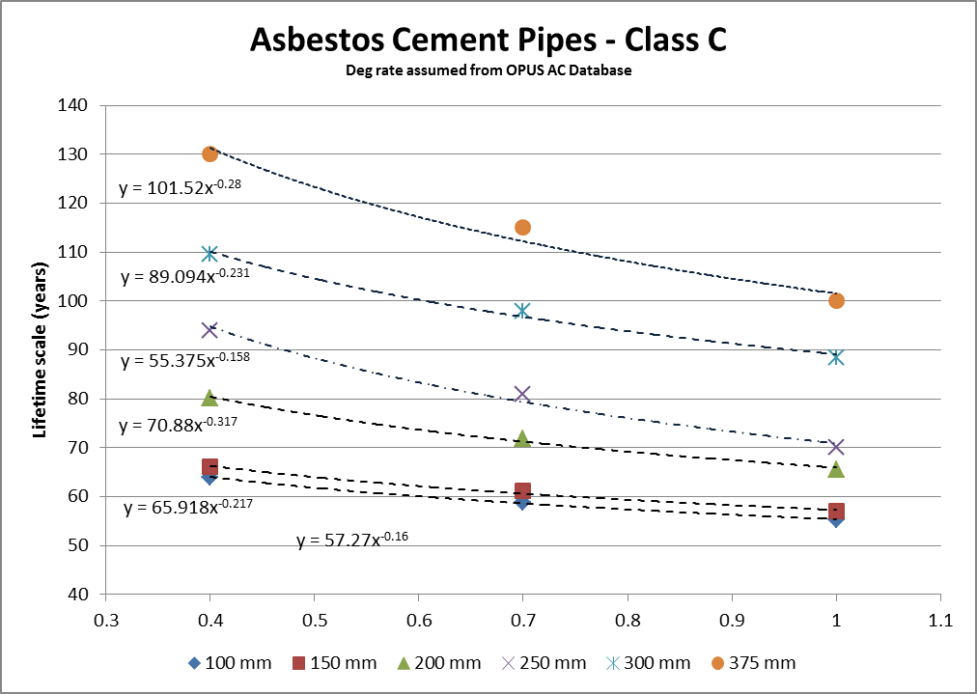

Figure 4‑12 Asbestos Cement – Class C





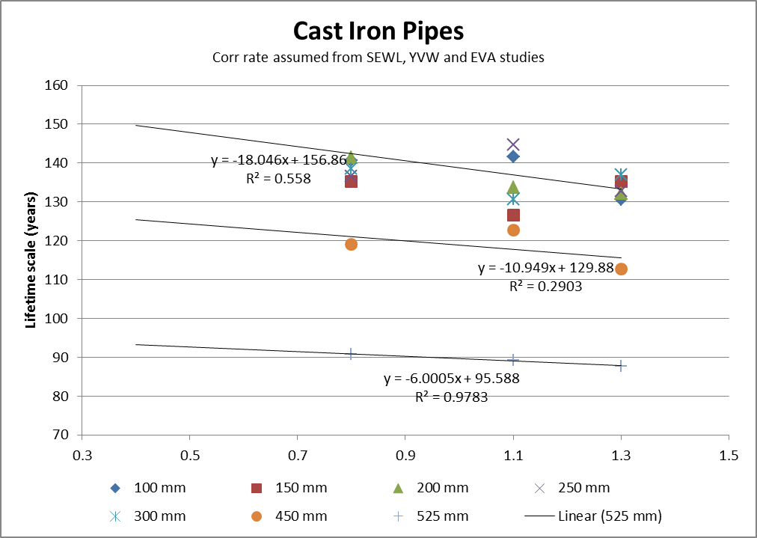

Figure 4‑13 Cast Iron

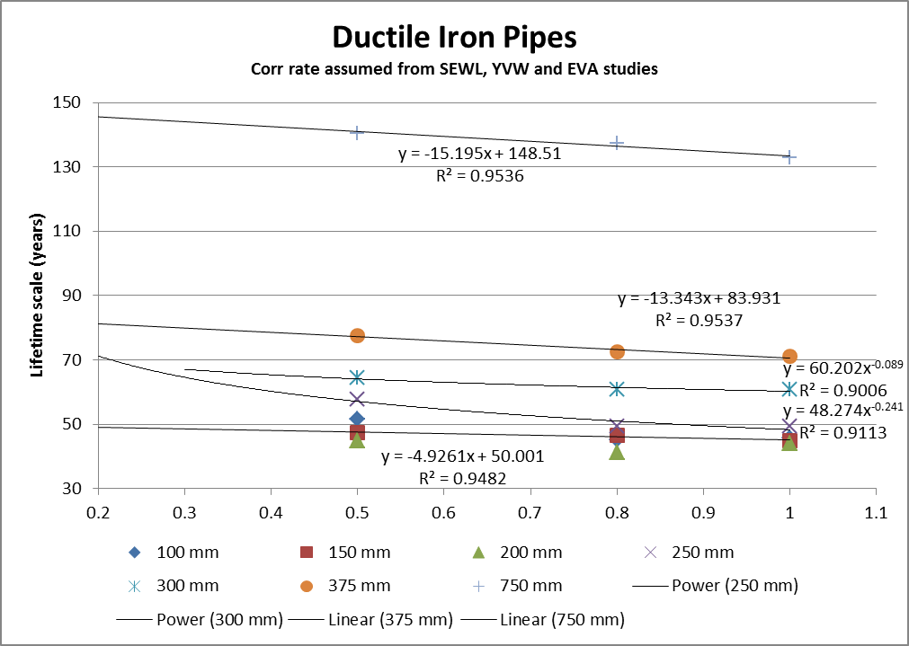

Figure 4‑14 Ductile Iron

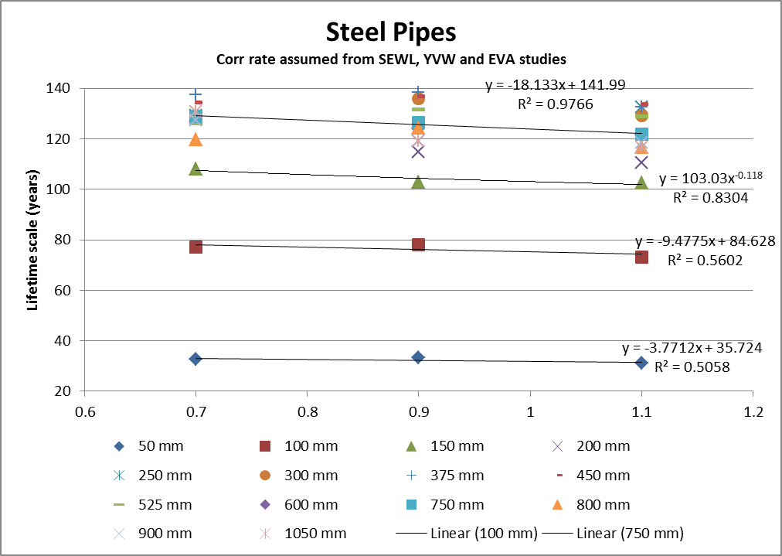

Figure 4‑15 Steel

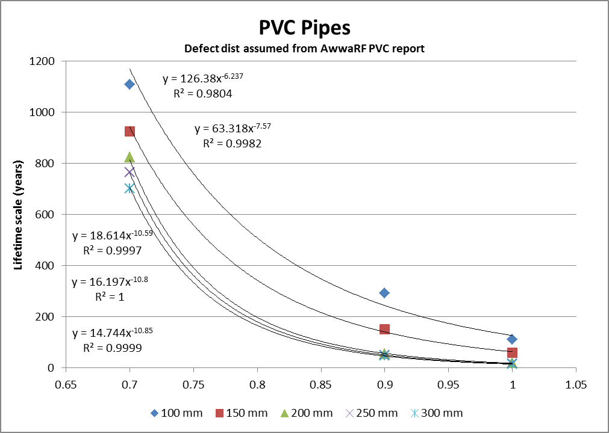

Figure 4‑16 PVC Pipes

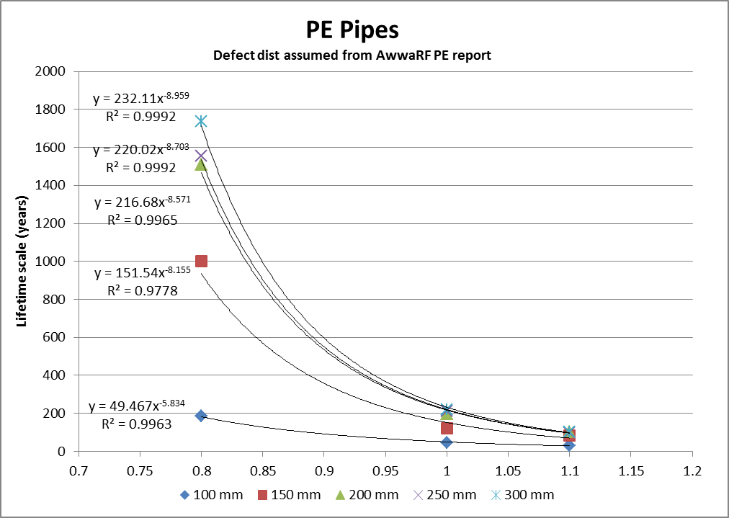

Figure 4‑17 PE Pipes

# Outcomes

## Background

As with any mathematical model, the assumptions and input data will significantly influence the outcomes. For the three water networks, there are generally a number of discrepancies including missing attribute data such as

* diameters,
* materials and
* lengths or
* year laid dates.

The number of discrepancies is not likely to affect the deterioration profiling for water distribution pipes as it relies on establishing a failure density curve based on typical material types, operating pressures, diameter and other applicable factors.

However, data variability does impact the outcomes when the deterioration profiles are applied to the actual asset database to develop renewals forecasts.

* Distribution network forecasts use the installation data and forecast remaining life for a particular material type / diameter / operating pressure / location to determine the estimated first failure time and assign this estimated time to the particular length and applicable unit rate to create a renewals forecast.
* Collection networks now also forecast using the installation date and a forecasted remaining life for a particular material / diameter to determine the estimated failure time assign this estimated failure time to the particular length and applicable unit rate to create a renewals forecast.

## Condition Grading

The key outcome from the development of statistical deterioration models is to identify a more robust renewals forecast. In order to do this we first need to estimate the likely condition grade and the most suitable intervention date.

For the purposes of this study:

* **Distribution:** the intervention time is made up of the estimated first failure time and a lag. The lag period has yet to be calculated and would be different for each material type and width. We have however (for now drawn a line in the sand) and assigned a lag of zero years for pipes less than 100mm in width; 10 years for other AC pipes and 20 years for all other materials.
* **Collection:** the estimated failure time has been set at 90% along the cumulative probability curve generated by the MLM tool. In other words the assets will be run almost to failure.

The condition grading tables reflect the variable performance characteristics of the different materials. This is broadly based on findings from international research.

| Network | Material | Size | Condition Rating (Cumulative Probability) | | | | | Comments |
| --- | --- | --- | --- | --- | --- | --- | --- | --- |
| 1 | 2 | 3 | 4 | 5 |
| Water Supply | AC | All | 0.22 | 0.55 | 0.7 | 0.83 | 0.95 | Broad findings from International research |
| CI unlined | All | 0.3 | 0.7 | 0.85 | 0.92 | 0.98 |
| CI lined | All |
| DICL | All |
| Steel lined | All |
| Steel unlined | All |
| PVC | All | 0.4 | 0.85 | 0.9 | 0.97 | 0.995 |
| PE | All |
| Generic | All | 0.3 | 0.5 | 0.7 | 0.8 | 0.9 | Assumed |
| Storm  water | CC | <375 | 0.2 | 0.5 | 0.7 | 0.8 | 0.9 | Estimates to be confirmed from international research  (or otherwise agreed in principal) |
| CC | >=375 & <750 |
| CC | >=750 |
| Wastewater | AC | All |
| AC | 150 |
| EW | All |
| CC | 250 |
| PVC | All | 0.4 | 0.85 | 0.9 | 0.97 | 0.995 |
| PE | All |
| Generic | All | 0.3 | 0.5 | 0.7 | 0.8 | 0.9 | Assumed |

Table 5‑1 Condition Grading Tables

## Estimated Renewals

The key outcome from the development of the statistical deterioration models is to identify a more robust renewals forecast that would enable more effective use of capital and operational funding across the network over the short, medium and long term renewals horizons. In generating the renewals forecast:

* Secondary renewals have not been included
* Forecasts cover pipe assets
* Unit rates are based on the December 2014 valuations

Figure 5‑1, present the renewals forecasts for the three water assets in the four local council areas.

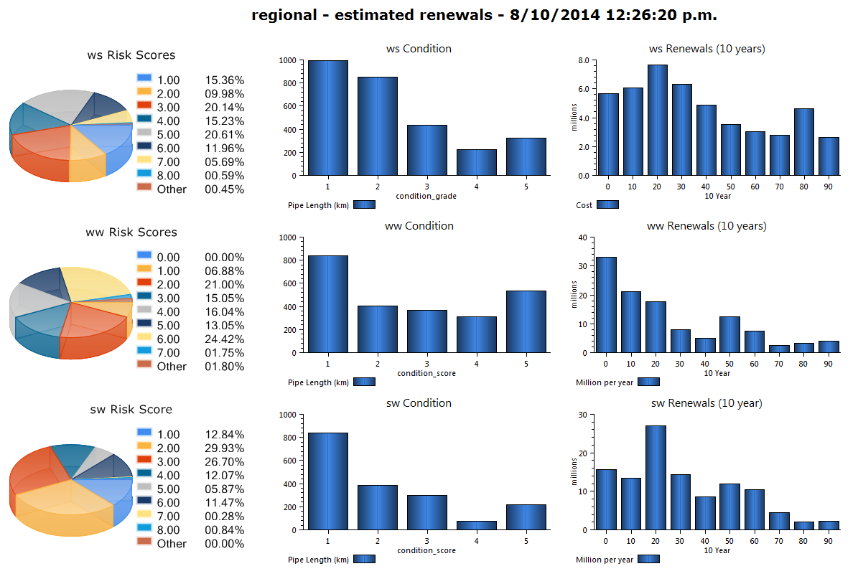

Figure 5‑1 InfoNet Dashboard - Interim

## Mapping

### Water Supply

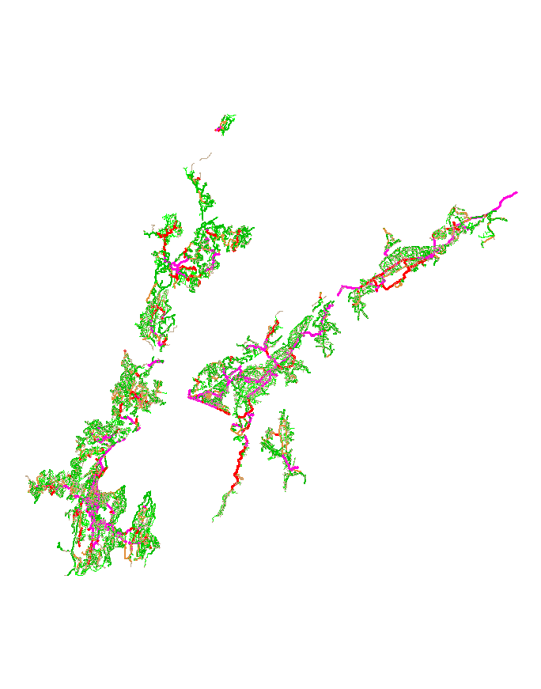

Legend

Light green > = 1; Dark green > = 2; Orange > = 3; Red > = 4; and Purple > = 5

Figure 5‑2 Pipeline Consequence Scores – Water Supply

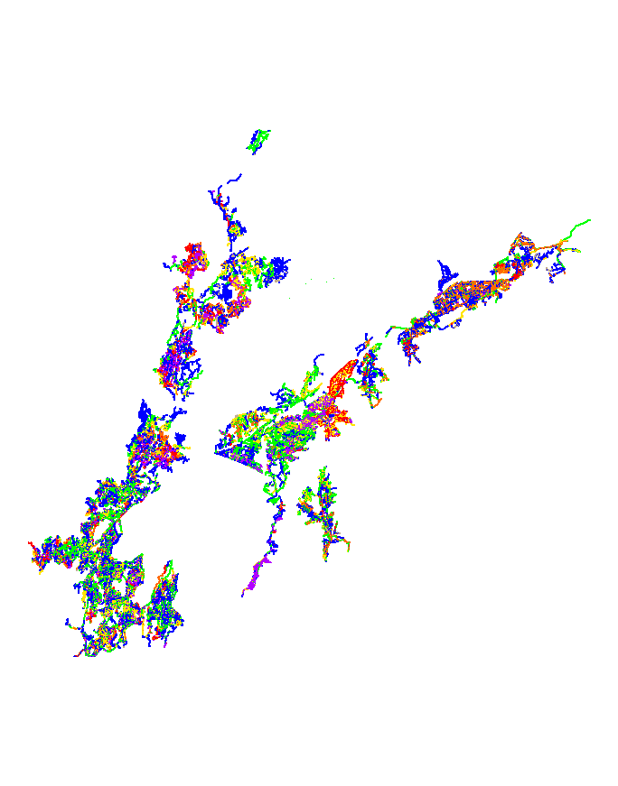

Legend

Dark blue > = 0; Light green > = 1; Yellow > = 2; Orange > = 3; Red > = 4; and Purple > = 5

Figure 5‑3 Pipeline Likelihood Scores – Water Supply

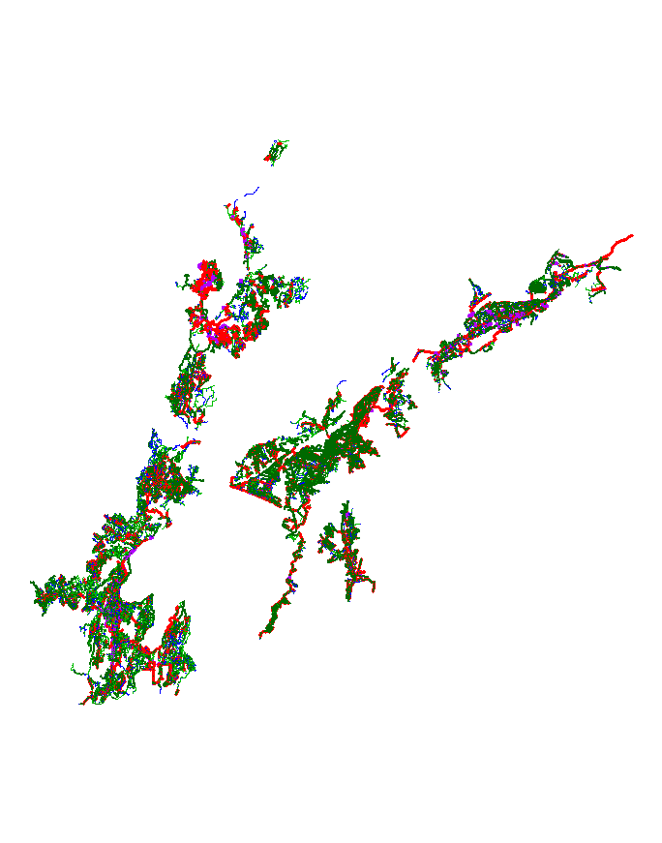

Legend

Light blue > = 0; Dark blue > = 1; Light green > = 2; Dark green > = 4; Red > = 6; and Purple > = 8

Figure 5‑4 Pipeline Risk Scores – Water Supply

### Wastewater

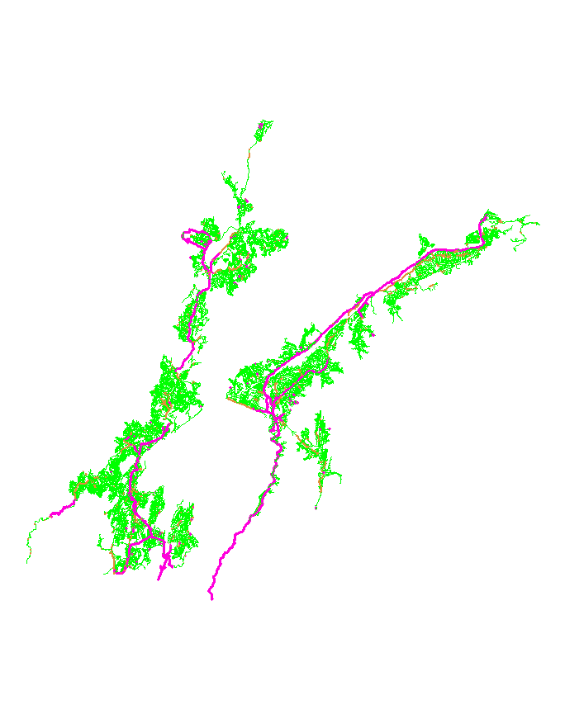

Legend

Light green > = 1; Dark green > = 2; Orange > = 3; Red > = 4; and Purple > = 5

Figure 5‑5 Pipeline Consequence Scores – Wastewater

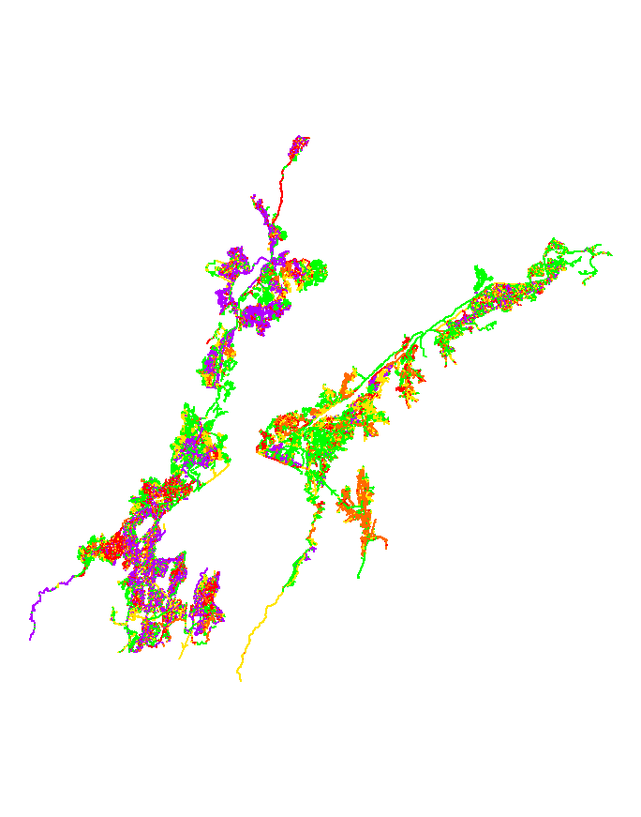

Legend

Dark blue > = 0; Light green > = 1; Yellow > = 2; Orange > = 3; Red > = 4; and Purple > = 5

Figure 5‑6 Pipeline Likelihood Scores – Wastewater

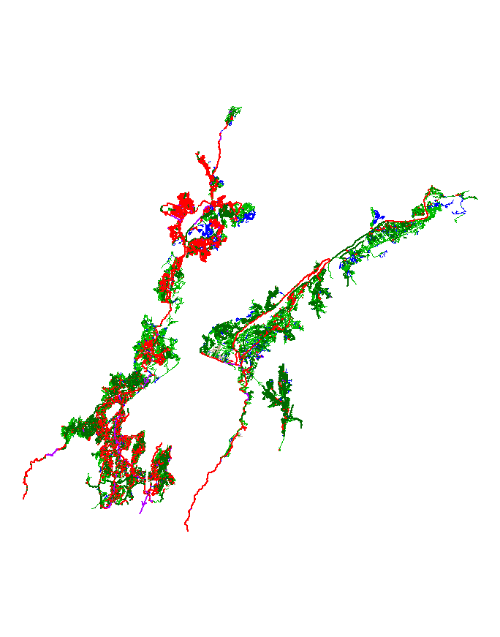

Legend

Light blue > = 0; Dark blue > = 1; Light green > = 2; Dark green > = 4; Red > = 6; and Purple > = 8

Figure 5‑7 Pipeline Risk Scores – Wastewater

### Stormwater

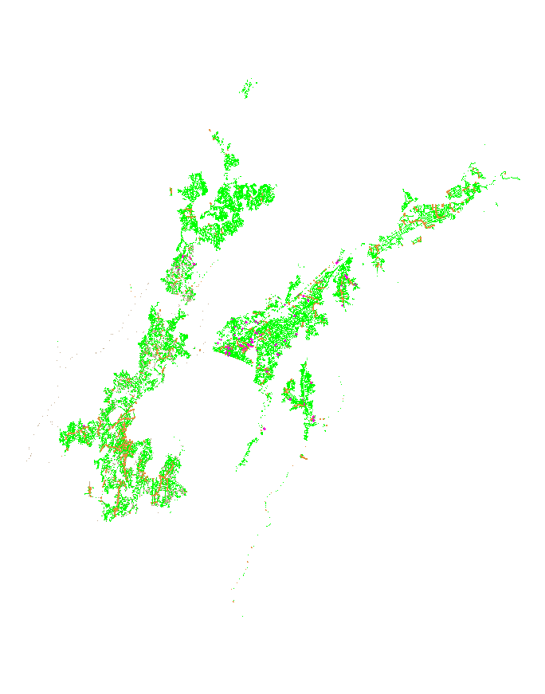

Legend

Light green > = 1; Dark green > = 2; Orange > = 3; Red > = 4; and Purple > = 5

Figure 5‑8 Pipeline Consequence Scores – Stormwater

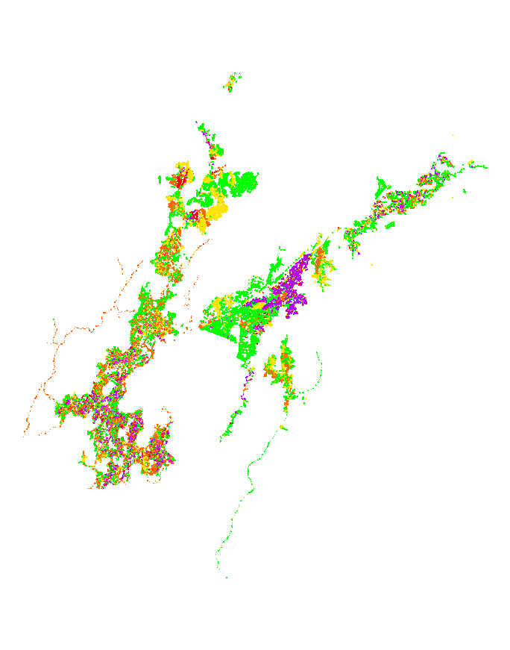

Legend

Dark blue > = 0; Light green > = 1; Yellow > = 2; Orange > = 3; Red > = 4; and Purple > = 5

Figure 5‑9 Pipeline Likelihood Scores – Stormwater

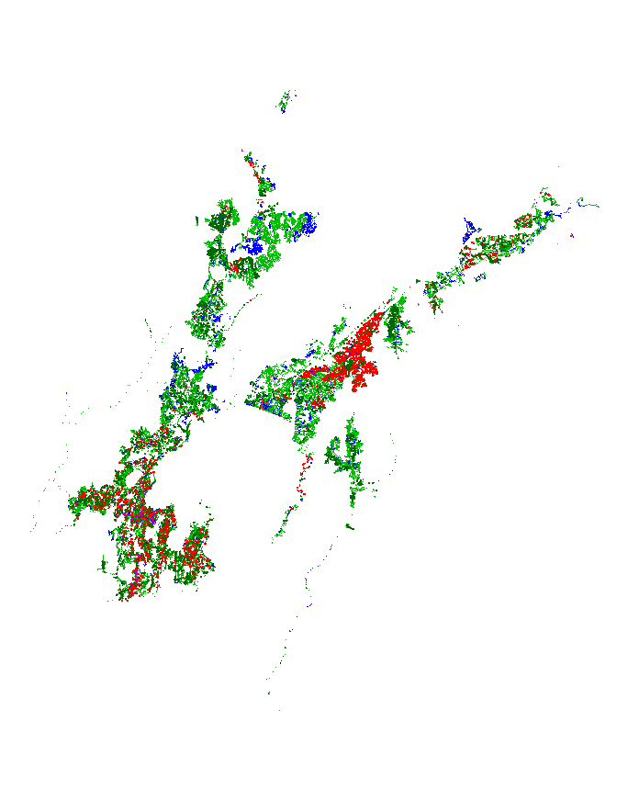

Legend

Light blue > = 0; Dark blue > = 1; Light green > = 2; Dark green > = 4; Red > = 6; and Purple > = 8

Figure 5‑10 Pipeline Risk Scores – Stormwater

# Critical Pipe Management

The approach for managing critical pipes should be different to that of non-critical pipes. Some of the main differences are as follows:

* **Repair policy:** with
  + non-critical pipes, breaks can be tolerated and running to pipe to failure should be accepted.
  + Conversely, critical pipes with no-tolerance for failure, a pro-active maintenance and rehabilitation policy should be adopted.
* **Information requirements**: The amount of information collected will vary according to the criticality of the pipe.
  + For non-critical pipes performance data such as breaks / blockages should be collected together with pipe attributes (such as material, diameter, age, depth etc.).
  + For critical pipes more detailed information pertaining to deterioration factors (soil, water quality, stray currents etc.), as well as observed distress indicators (cracking, pitting, joint displacement etc.) need to be collected and properly managed.
* **Level of detail**: The level of detail at which information is collected will also need to vary.
  + For non-critical pipes it is appropriate to collect information at a street level.
  + However for critical pipes it should be tracked at a more individual pipe-segment level.

## Inspections

### Collection Networks

The purpose of recommending regular survey work is to provide accurate data, so that the rehabilitation budget can be spent where it is most needed. The cost of inspection of these pipes is minimal, compared with the cost of the works required to carry out rehabilitation in even a small fraction of the group.

CCTV inspection frequencies should also take into account:

* **Additional CCTV**: reviews should be carried out for those pipes where frequent maintenance activities are being carried out. This may require Wellington Water to ensure that accurate records are being maintained of actual works undertaken related to the individual asset.
* **Pipes planned for rehabilitation:** The most severely degraded pipeline sections (those scheduled for rehabilitation within 3 years) should not be scheduled for further CCTV inspection, where existing survey information indicates that they are in need of rehabilitation as soon as possible. These assets would be inspected immediately prior to the rehabilitation process, and immediately afterwards.

A tentative strategy could then be something like:

Figure 6‑1 Tentative Strategy for CCTV Survey Planning

### Distribution Networks

In order to calibrate the condition models for the Water Supply network, various materials performance data is required.

As previously noted in reports prepared by AECOM, the sample size does not need to be large, however for a given sample at least three tests should be conducted.

| Material | Key parameter 1 | Key parameter 2 | Sampling required |
| --- | --- | --- | --- |
| AC | Wall section loss | Residual tensile strength | Extract coupons from failed pipe, pipe that is being renewed or sample from specific area of interest – measure wall section loss and residual tensile strength for at least 3 samples from the area of interest. |
| Cast iron / DICL | Wall section loss | Pit depth | Extract samples from areas of interest – at least 3 samples required from each area to provide statistically valid results |
| Steel | As for cast iron |  |  |
| Polymers (PVC, PE) | Inherent defect distribution |  | Sample from areas where failure experienced or areas with high dynamic loading possible (roadways) – examine pipe wall section for inherent defects that can act as nucleation points for crack growth – sample size may need to be larger for this material to get statistically accurate population |

Table 6‑1 Tentative strategy for pipe sampling

The focus for identifying sample areas should be those areas that are:

* Displaying signs of significant failure related service issues
* Areas forecast for renewal in the next 5 years
* Representative areas that cover the various installation conditions across the network (i.e. sandy soils, clayey soils etc.) – there is likely to be some overlap with the area characteristics defined above.

While our original advice suggested additional data was not required for AC, given that the model forecasts that this material could be expected to have a longer life that originally assumed, it is worthwhile collecting data to validate the model for AC.

In addition to the materials collection data, it is recommended that soil resistivity be assessed across the various areas of the network to assess the corrosivity of the ground.

# Works Cited

Davis, P. (2012). *Water Supply Condiiton Model - Remaining Useful Life Assessment.* Wellington: AECOM.

Davis, P., De Silva, S., Moglia, M., Gould, S., & Burn, S. (2008). Service Life Prediction and Scheduling Interventions in Asbestos Cement Pipelines. *Journal of Water SUpply and Technology: AQUA, 57, 4*, 239-252.

Opus. (2001). *New Zealand Asbestos Cement Watermain Manual.* Christchurch: NZWWA.

Wooley, K. (2012). *Regional Water Model Specification v3.* Hutt City, Upper Hutt City and Wellington: Capacity.

Appendices

## Description of Statistical Deterioration Model

### Pressure Networks

The following summarises the approach adopted by AECOM to forecast failure probability vs. age and expected failure rate vs. age curves for buried pressure pipelines.

Our predictive models are currently being used by a number of global water authorities to prioritise future interventions in critical pipeline assets. Models are also being used to forecast future expenditure associated with failures in large pipe networks.

The following aspects of our model are described below:

* Model components
* Pipeline materials covered
* Examples

1. **Model components**

The schematic diagram below shows the main components of predictive models for pipeline deterioration and failure.



Figure 7‑1 Schematic of model components

As shown, the main component is an established understanding of the dominant deterioration processes and failure modes that occur in the full range of pipeline materials. Examples are pitting corrosion and fracture in cast iron pipes, cement leaching/acid attack leading to strength loss and erosion in asbestos cement pipes and fracture from inherent defects in plastic pipelines

Based on this understanding we have developed predictive models and failure criteria that capture the mechanism of failure in service, together with a library of typical input variables for modelling deterioration and failure in different pipe materials. For this secondary component, we recognise that deterioration processes for buried pipelines are inherently uncertain and our library of deterioration rates contains suitable probability distributions for variables. Examples are the range of probability distributions we have developed for external surface corrosion rates in cast iron pipes, which is based on values in the literature and from our own previous condition assessments.

Our models then combine these model variables together with known operating conditions (i.e. internal pressure, external loading etc) to estimate failure probability vs. age curves (for critical pipelines such as large diameter Cast Iron water supply or Asbestos Cement sewer rising mains) and/or expected failure rate vs. age curves (for larger pipe networks, such as PVC reticulation pipes)

1. **Available models for different pipe materials**

Currently we have developed models, complete with libraries of input variables, for the three main pipeline materials groups: Plastics; Cement-based and Metallics.

The table below summarises the components of these models that we have completed and can be applied in practice.

| **Pipe material** | **Deterioration/Failure mode** | **Model input libraries developed** | **Model outputs delivered** |
| --- | --- | --- | --- |
| PVC (sewer and water) | * Crack initiation * Slow crack growth * Brittle fracture | * Defect size * Fracture toughness | * Failure probability vs. age (critical mains) * Expected failure rate vs. age (non-critical) |
| Polyethylene (sewer and water) | * Crack initiation * Ductile crack growth * Localised crack | * Defect size * Craze strength | * Failure probability vs. age (critical mains) * Expected failure rate vs. age (non-critical) |
| Asbestos Cement (sewer and water) | * Cement leaching and strength loss (water) * H2S attack (sewer) | * Rate of loss of pipe wall strength * Rate of loss of pipe wall thickness (sewer) | * Failure probability vs. age (critical mains) * Expected failure rate vs. age (non-critical) |
| Cast Iron (Water) | * Corrosion (graphitization) * Fracture from corrosion defects | * Corrosion rate (graphitization) | * Failure probability vs. age (critical mains) * Expected failure rate vs. age (non-critical) |
| Steel/Ductile Iron (Water) | * Corrosion (pitting) * Excessive deflection/Buckling failure * Ductile rupture | * Pitting corrosion rate | * Failure probability vs. age (critical mains) * Expected failure rate vs. age (non-critical) |

1. **Background - Monte Carlo simulation models for buried pipelines**

For a particular pipe material, Monte Carlo simulation models generally follow the algorithm below:

1. Input pipe material
2. Input pipe attributes
   1. Diameter,
   2. Original wall thickness
   3. Installation year
3. Input pipe operating and installation conditions
   1. Internal pressure
   2. Soil cover depth
   3. Soil type
   4. Surface loading
4. Assign stochastic degradation rate parameters that describe deterioration
   1. Specify probability distribution to characterise degradation process (i.e. Weibull distribution)
   2. Expected (Mean) deterioration rate (i.e. corrosion rate in mm/year)
   3. Variance in deterioration rate
5. Set up hypothetical population of *N* pipe samples (i.e. *N* = 10,000)
6. Assign pipe attributes, operating and installation conditions to each pipe in sample
7. Randomly assign degradation rate to each pipe in sample (following specification in steps 4a, 4b and 4c)
8. Increment time
   1. Calculate increment in degradation (i.e. increase in corrosion pit depth) for each pipe in sample
   2. Check whether criterion for structural failure of pipe is satisfied
   3. Record time for pipes that have failed
   4. Return to step 8)
9. Store predicted failure times for each of the *N* pipes in sample
10. Calculate expected failure time from data in step 9)

As shown, the models require pipe attributes to be described along with anticipated operating pressures and external loads. The key requirement however is to define the probabilistic process by which pipe degradation proceeds.

Depending on the pipe material, this involves specifying a probability distribution for processes such as graphitic corrosion rate in cast iron pipes; pitting corrosion in ductile iron and steel pipes; rate of strength loss in Asbestos Cement pipes.

The Monte Carlo simulation then samples from this probability distribution and assigns a degradation to a number of hypothetical pipes in a sample (a sample size of *N* = 10,000 is commonly used). The time to failure for each of the simulated N pipes in this sample is then calculated based on established physical failure models. Examples are:

* Fracture of corroded Cast Iron pipes under combined internal pressure and external loads
* Pitting corrosion through the pipe wall for Ductile Iron and Steel pipes
* Rupture of Asbestos Cement pipes under combined pressure and external loads after strength loss over time

The output of the Monte Carlo simulation model is simply a list of *N* numbers that in each case, correspond to the age when failure in predicted to occur in each of the *N* pipes in the sample that was simulated.

Because the degradation rate is sampled in each case from a probability distribution, then the corresponding predicted time to failure also varies in the sample of *N* pipes. Variation in predicted failure time can be fitted to its own probability distribution.

Although any probability distribution can be used for this purpose, previous experience with buried pipeline failure modelling indicates that the 2-parameter Weibull distribution is widely applicable. The Weibull cumulative probability distribution for pipe lifetime is described as

 (1)

where *F(t)* is the probability that the simulated pipe lifetime is less than a particular value *t*. ** is the scale parameter of the Weibull probability distribution function and *η* is the shape parameter. Scale and shape parameters can be obtained by fitting the Weibull distribution to an empirical probability estimate from the raw simulated pipe lifetimes.

Once the Weibull distribution is fitted and the lifetime scale and shape parameters are obtained, an expected failure time can then be calculated, which is the mean predicted failure time in the simulation. Subtracting the actual pipe age from this gives an estimate of the expected Remaining Useful Life (RUL) for that asset.

1. **Application of models to Wellington Water data**

As described previously, AECOM have a set of existing Monte Carlo simulation models that cover a range of different pipeline materials. As a first approximation, these models can be applied to the pipes in the Wellington Water database and table 1 above shows the particular pipe materials that have been covered in this initial study. The application of Monte Carlo simulation models to develop condition grades is achieved in four stages as shown in Figure 7‑2below:

**Stage 1 – Generate outputs from Monte Carlo (MC) simulation model**

* Establish input parameters for each pipe material
  + Degradation rate
  + Internal pressure
  + Diameter
* For each pipe material, run simulations and fit MC simulation results to Weibull probability distributions for different combination of pressure and diameter
* For each material, establish empirical relationships that capture variation in Weibull scale and shape parameters with internal pressure and pipe diameter

**Stage 2 – Assign lifetime probability distributions to each pipe in database**

* Use the Weibull parameters/pressure/diameter relationships established in stage 1 to assign lifetime scale and shape parameters to each pipe (line item) in the Wellington Water database

**Stage 3 – Assign condition grade based on % Useful Life (UL) remaining**

* Based on the assigned Weibull scale and shape parameters, calculate the Useful Life (expected failure age) for each pipe (line item) in Wellington Water database
* Subtract the current age from UL (developed in stage 2) to estimate the percentage of UL remaining
* Assign a qualitative condition grade for each pipe (line item) based on % UL remaining

**Stage 4 – Derive decay curves for each pipe material for input into existing asset renewals models**

* Plot the variation in assigned condition grade with pipe age for each material
* Assign a qualitative condition grade for each pipe (line item) based on % UL remaining

Figure 7‑2 Methodology for application of Monte Carlo simulation models to Wellington Water database

1. **Stage 1 – Generate outputs from Monte Carlo simulations**

As shown in figure 2, the first stage of the methodology uses the Monte Carlo simulation model to generate lifetime parameters for each pipe in the database. The individual sub-stages required are described below.

* 1. *Assumptions for Monte Carlo simulation inputs*

Usually, the parameters that describe the probability distribution for degradation processes are obtained from inspection and non-destructive testing on number of pipes within a network.

However, no such investigations have been conducted yet on the Wellington Water network and, as a first approximation, model input parameters can be based on the large number of previous studies conducted in this area by the AECOM team.

This kind of desktop assessment allows the Monte Carlo simulations to be run and required lifetime probability distributions to be estimated in the absence of previous investigation data.

Table 7‑1 summarises the inputs that have been assumed in this current study.

|  |  |  |  |
| --- | --- | --- | --- |
| **Pipe material** | **Information sources** | | |
| **Original wall thickness** | **Degradation rate: Probability distribution** | **Soil type/Cover/External loads** |
| Asbestos Cement | Hardies pipe manufacturing data | Ref [1] | Ref [1] |
| Cast Iron | Australian Iron and Steel (AIS) Catalogue, 1953 | Ref [2] | Ref [2] |
| Steel | API Schedules | Ref [3] | Ref [3] |
| Ductile Iron | Australian/New Zealand Standard AS/NZS 2280 | Ref [2] | Ref [2] |
| Polyethylene | Australian/New Zealand Standard AS/NZS 4130 | Ref [4] | Ref [4] |
| PVC | Australian/New Zealand Standard AS/NZS 1477 | Ref [5] | Ref [5] |

Table 7‑1 Inputs to Monte Carlo simulation models

1. **Use of the failure models by Wellington Water**

With the AECOM pipeline failure models established, together with existing input data libraries, they can be used to generate outputs of the type shown above.

As a first step, the existing AECOM input data libraries are used to generate failure probability/expected failure rate vs. age curves across the existing pipeline asset databases. This desktop assessment can be combined with estimated failure costs (again from the AECOM database) to provide a perceived risk associated with different pipes in the network. This perceived risk can then be used by Wellington Water to rank pipes in order of their justification for more detailed inspection/investigation.

We note that after this initial reliance on AECOM input data libraries, as more historical condition, failure or leakage data becomes available, we are also able to amend the parameters of the model, ‘tuning’ it such that it fits the growing observed database of actual failure events.

*The current benefit is that the models can be applied now as a first approximation, without relying on potentially expensive investigations to gather model input data.*

## Notes on Failure Methods

The following records the review of defect types and deterioration patterns for varying materials to assess whether there was any reason to believe that a defect in one pipe indicated more severe deterioration than a defect in another pipe. It appears that the defect itself is indicative of material type and given the poor confidence in the material type information it was decided to use the same defect score regardless of material type.

1. Earthenware pipe (EW). There can be large variations in the quality of EW, both in the manufacture and in the installation. It is suspected that most observed damage is due to poor installation, and will generally be recorded as “JF” which describes defects within 100mm of the joint. EW does not include vitrified clay pipe (coded as VC) which is manufactured under very strict tolerances and quality assurance requirements. The deterioration profile of EW does not appear to have been formally researched and little is known about it. Anecdotal opinion is that most of the damage to it happens during and immediately after installation. Thereafter deterioration can occur due to:

* + New superimposed loads, particularly those associated with, and caused by, earthworks.
  + Possibly earth movement as surrounding clays dry out and shrink in the summer then become re-moisturised and expand in the winter.
  + Earth movement due to seismic activity, although this is rare in the Auckland region.
  + Earth movement due to unstable slopes. An example of this was identified in North Shore along a stream bank in the Awaruku area.
  + Tree roots may exacerbate deterioration but will generally do little more than fill already-existing holes through the pipes or mortared joints.
  + Infiltration / exfiltration which can put additional pressure on existing defects. However this is less likely to be an issue in the clay soils that are common throughout North Shore City.
  + New connections, although current NSCC requirements, new materials and a general improvement in drain laying standards make this less of an issue.

Although EW pipelines are generally regarded as having a life expectancy of circa 80 years, there are numerous examples of such pipelines in almost perfect condition after 100 years. This is normally due to ideal laying conditions, and presumably, good installation workmanship.

2. Asbestos Cement pipe (AC). It is understood that there are two types of asbestos cement pipe in New Zealand. The first imports of AC are believed to have originated from Italy and quickly deteriorated in the presence of groundwater. However most of the AC pipe in New Zealand originated from Australia and was of higher quality. Due to its long length (4 metres) and lack of steel reinforcing, AC pipe is sensitive to poor quality bedding. Discontinuous bedding will result in large circumferential cracks. This will result in an increase in I/I and exfiltration but will not be structurally significant as the ring bending stress will not be affected. Structural deterioration of asbestos cement can be due to:

* + Erosion of the invert on steep slopes, due to abrasion.
  + Interior corrosion due to H2S formation.
  + Exterior corrosion due to natural soil conditions. There appears to be no formal research into this phenomenon but there is anecdotal evidence that it can seriously affect the structural integrity. It is usually detected only when there is catastrophic failure and if there is any history of this happing in North Shore investigations should be carried out to determine how wide-spread it is.

Longitudinal or multiple cracking is unusual in AC pipe, probably due to the fibrous reinforcement which would effectively provide crack control.

3. Spun concrete pipe (CS). This is most likely to be found in larger diameter trunk sewers, although there was a period prior to the availability of asbestos cement when it was commonly used for 150mm and 225mm pipelines. Spun concrete pipes were generally manufactured to high quality standards although there has been evidence of inconsistent quality controls. They are reinforced and the concrete strength is typically 45 – 55 MPa. The most common concern in early concrete pipelines was the biodegradation of the rubber rings used for sealing, leading to massive increase in I/I and exfiltration but having no structural significance. Not all rubber rings were prone to biodegradation and in later installations chemicals to prevent this were incorporated in the rubber. Structural degradation of concrete pipes is commonly due to:

* + Erosion of the invert on steep slopes, due to abrasion.
  + Interior corrosion due to H2S formation.
  + Overloading. This can be temporary (most commonly earthworks operations) or permanent (most commonly due to increased cover.) Due to the nature of reinforced concrete there is typically multiple cracking when loads are applied. This signifies only that tension loads have been taken up by the reinforcing, and does not signify a loss of strength. When design loads are exceeded there will typically be longitudinal cracking (especially at the soffit and invert) with the cracks exceeding 0.5mm. Such cracking introduces two concerns. The first is that the design loads have been exceeded and pipe failure could occur, particularly if there is evidence of deformation. The second is that the reinforcing will be subject to corrosion. This is a more measurable deterioration factor and if detected in time, can be virtually eliminated by installing a structural liner.

4. Precast concrete pipe (CP). These were typically installed prior to the availability of spun concrete pipe. Anecdotal evidence is that construction quality was variable and that there is a history in North Shore of sudden catastrophic failure of CP pipes with little pre-warning. There is often evidence of corrosion, indicating that concrete strength was particularly unreliable. Due to the history of precast concrete pipe it is proposed that all such pipelines be considered for urgent replacement. However there are two issues that need to be taken into consideration. First, larger diameter precast concrete pipelines that may have been purpose-made for a project, could have been made to stricter quality assurance standards, and may still be in good condition. Second, it is common for CCTV inspection operators to mis-record concrete pipe material in the “Material” field. This could give a false impression of the extent of CP in North Shore.